**Solution of Paper :**

**ISE I :**

Question 1:

1. Answer:

If we declare any local variable without initializing it’s value and using it in the code causes error such in result.

1. Answer:

We can use the substring method to check that the registration number is of IT department or not.

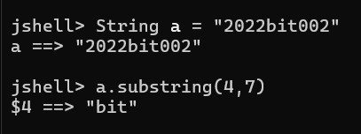

Question 2:

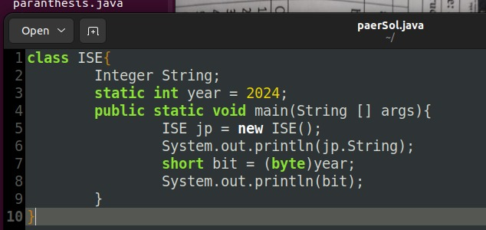

Answer:

1. Static keyword allocate the memory just once.This means we'll create only one instance of that static member that's shared across all instances of the class.

b.

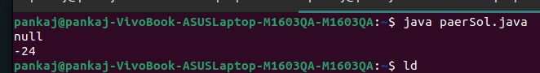

**MIDTERM**

Question 1 :

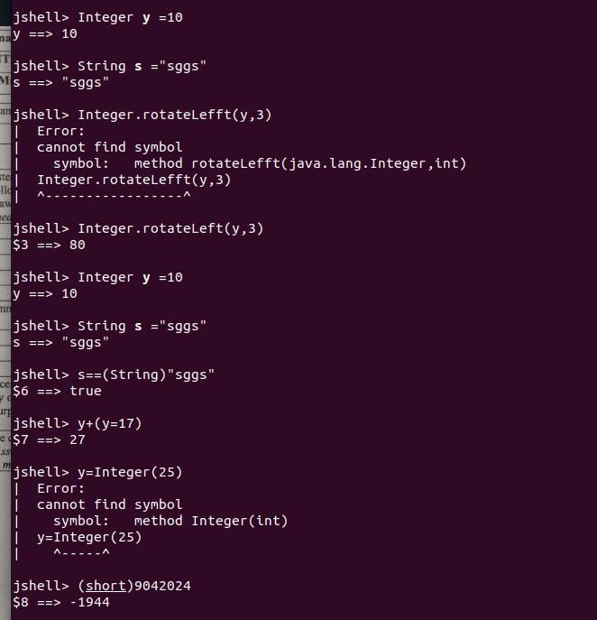

Question 4:

a.

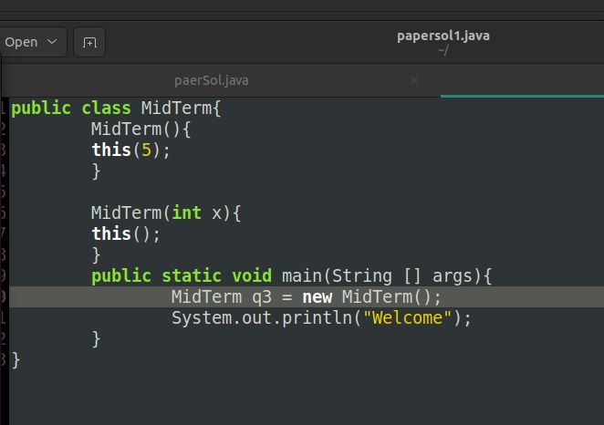

Answer:

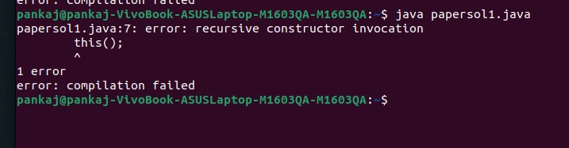

b.

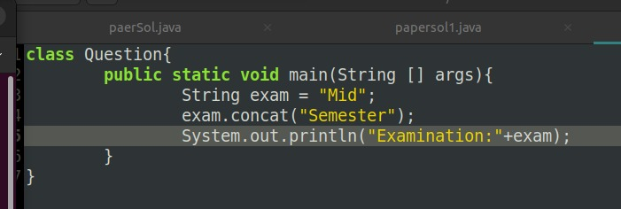

Answer:

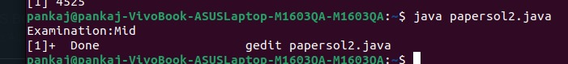

c.

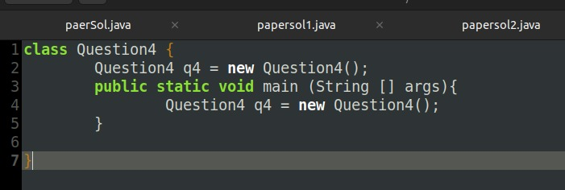

Answer;

STACK OVERFLOW.

d.

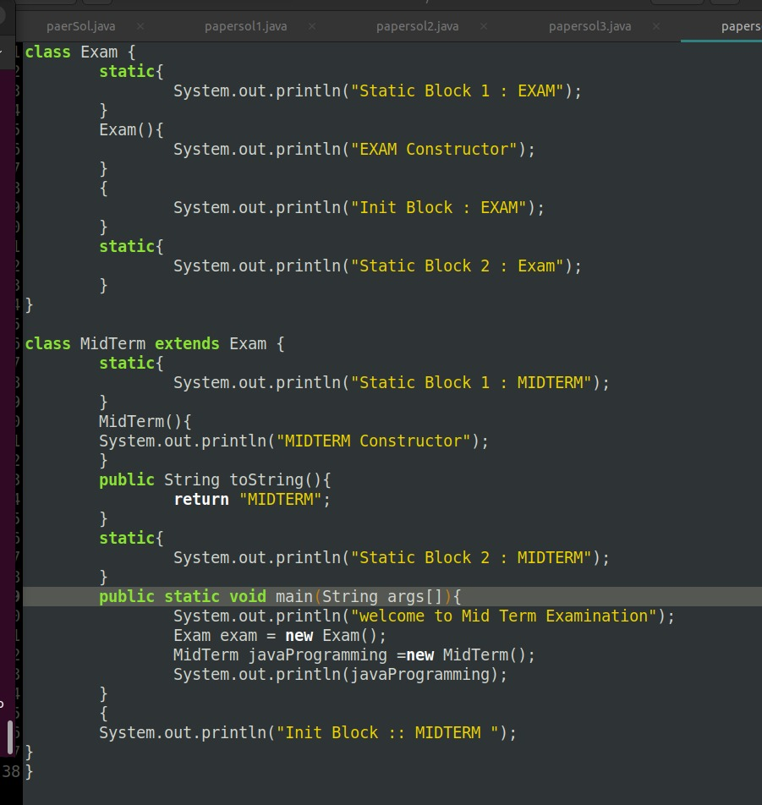

Answer :

Static Block 1: Exam

Static Block 2: Exam

Static Block 2: MidTerm

Static Block 2: MidTerm

Wel Come to Mid Term Examination

Init Block : Exam

Exam Constructor

Init Block : Exam

Exam Constructor

Init Block : MidTerm

MidTerm@56312

Question 5:

Answer:

There will be three objects created in the given question.